**Capstone Project:**

**Medicare**

**Document contains:**

* Project and developer details
* Sprints planned and the tasks achieved in them
* Core concepts used in the project
* Links to the GitHub repository to verify the project completion

**Project and developer details**

**DESCRIPTION**

Create a dynamic and responsive Java e-healthcare web application for ordering medicines of different categories.

Background of the problem statement:  
Medicare is a company that supplies medicines and a couple of other healthcare essentials at an affordable price. It was established in 2012 in Delhi, India. It had been serving fine all these years, however, the business analysts noticed a decline in sales since 2017. They found out that online ordering of medicines with companies, such as 100mg and mfine are gaining more profits by eliminating middlemen from the equation. As a result, the team decided to hire a Full Stack developer to develop a healthcare web application with a rich and user-friendly interface.  
You are hired as the Full Stack Java developer and are asked to develop the web application. The management team has provided you with the requirements and their business model so that you can easily arrange different components of the application.

Features of the application:

1. Registration
2. Login
3. Payment gateway
4. Searching
5. Filtering
6. Sorting
7. Dynamic data
8. Responsive and compatible with different devices

**Admin Portal:**  
The admin portal deals with all the backend data generation and product information. The admin user should be able to:

Add or remove medicine details from the application to build a rich product line

Edit medicine details like name, price, seller, product description, and offers to keep the product information updated with the current prices

Enable or disable a medicine product

**User Portal:**  
It deals with the user activities. The end-user should be able to:

Sign-in to the application to maintain a record of activities

Search for products based on the search keyword

Apply filters and sort results based on different cuisines to get the best deals

Add all the selected food items to the cart and customize the purchase at the end

Perform a seamless payment gateway

Get an order summary details page once the payment is complete

**Developer Details**: Aditya Nair

[Newadit1704@gmail.com](mailto:Newadit1704@gmail.com)

8369400977

**Sprints planned and the tasks achieved in them**

There are four sprints for this project

Sprint-1: Studied the Features of application and created Git Repository.

Sprint-2: Medicare backend created using spring boot and tested backend API

Sprint-3: Medicare frontend created using spring boot and connected with backend.

Sprint-4: Medicare application all features is tested.

**Recommended technologies**

Database management: MySQL

Backend development: Java programming, Eclipse, Spring Boot

Frontend development: JSP, Angular, Bootstrap, HTML/CSS.

**Output**

1. **Starting of backend Spring Boot Application.**

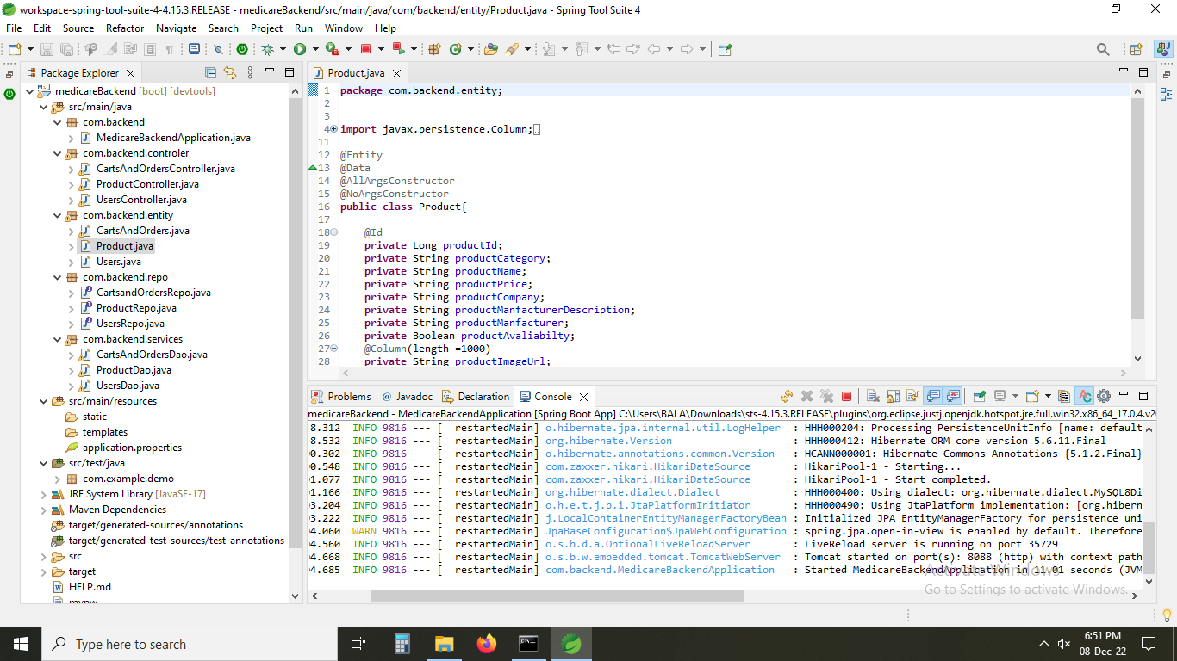

1. **opening of vs code.**

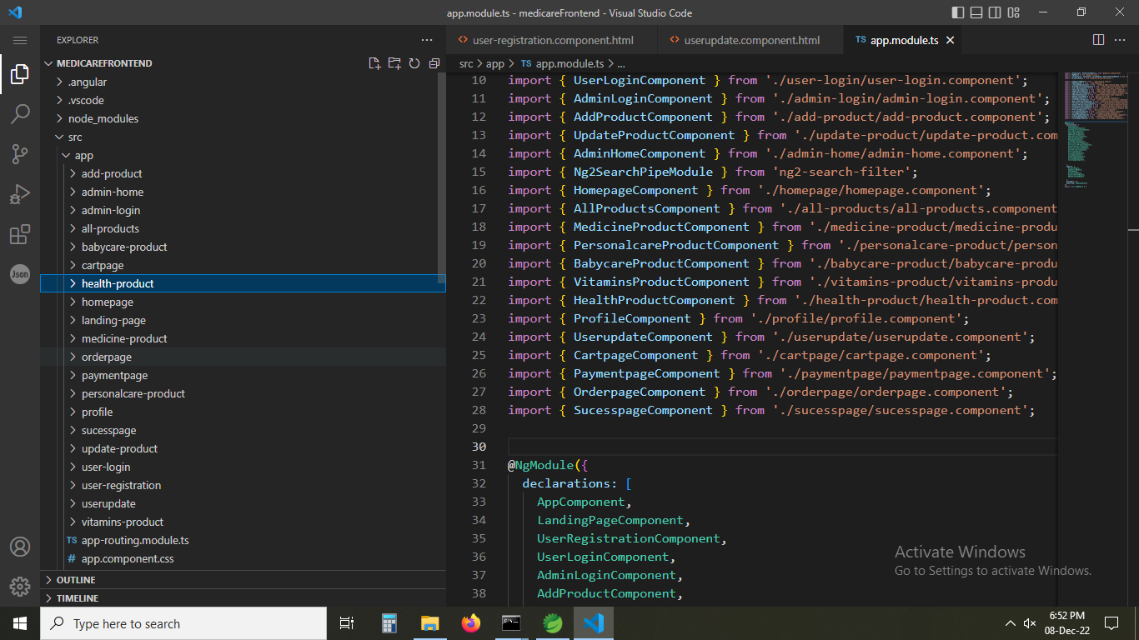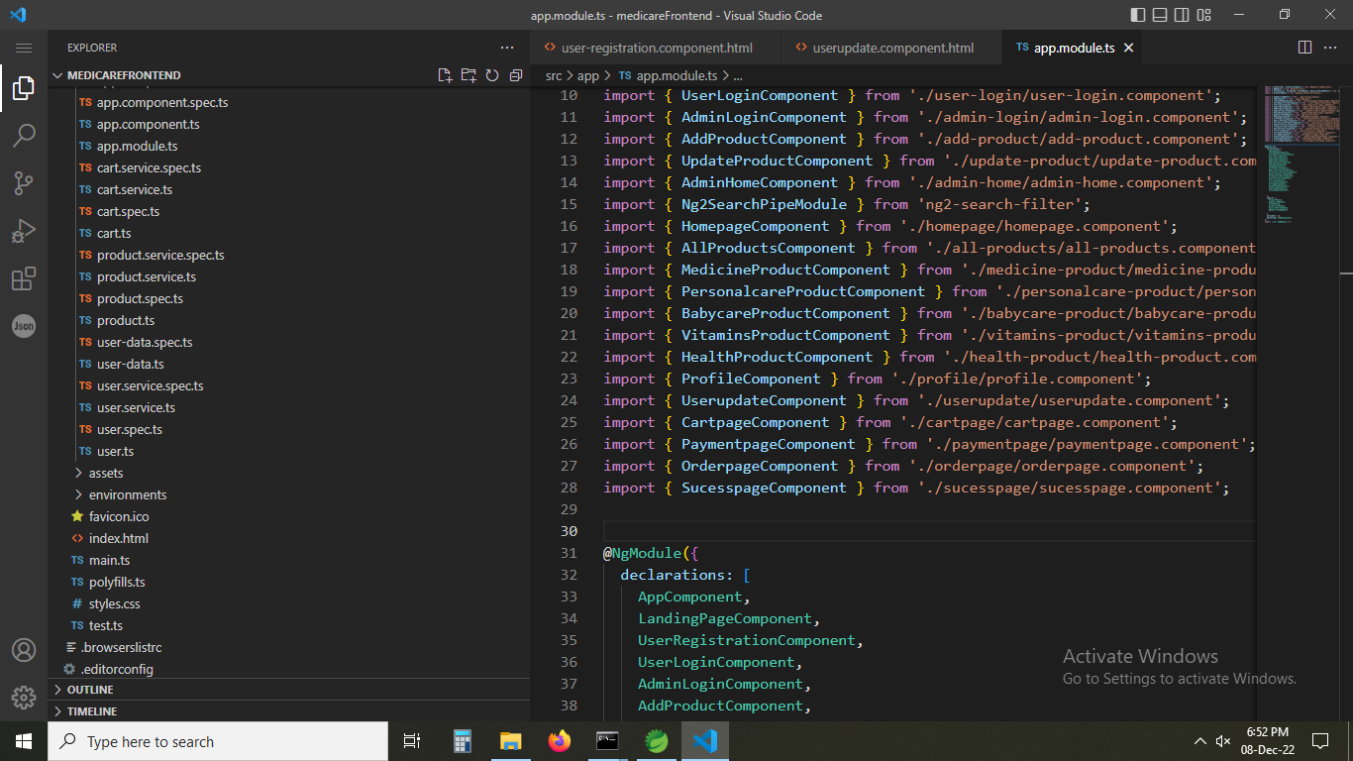

1. **opening the path in cmd and using ng serve code to start angular frontend application.**

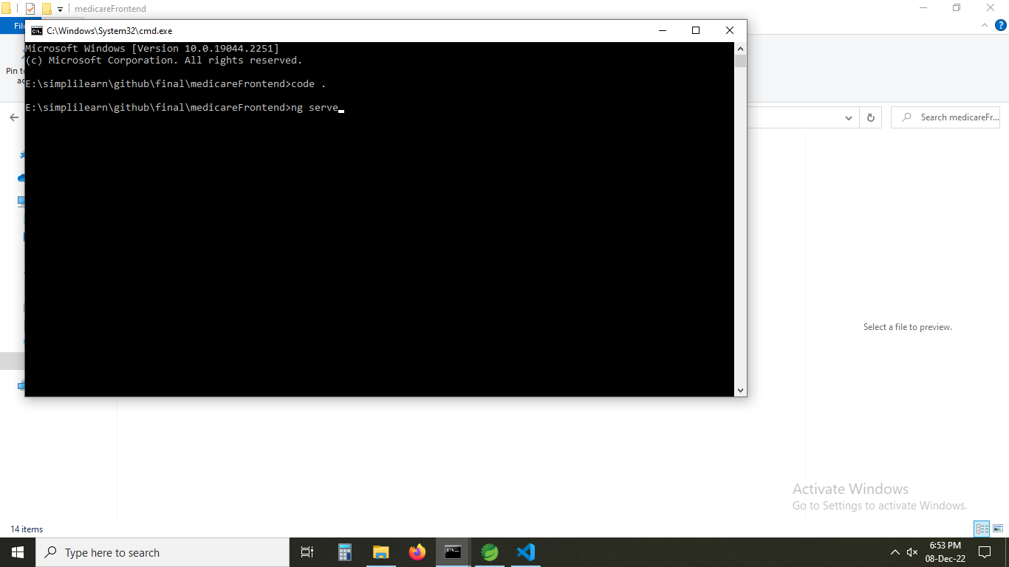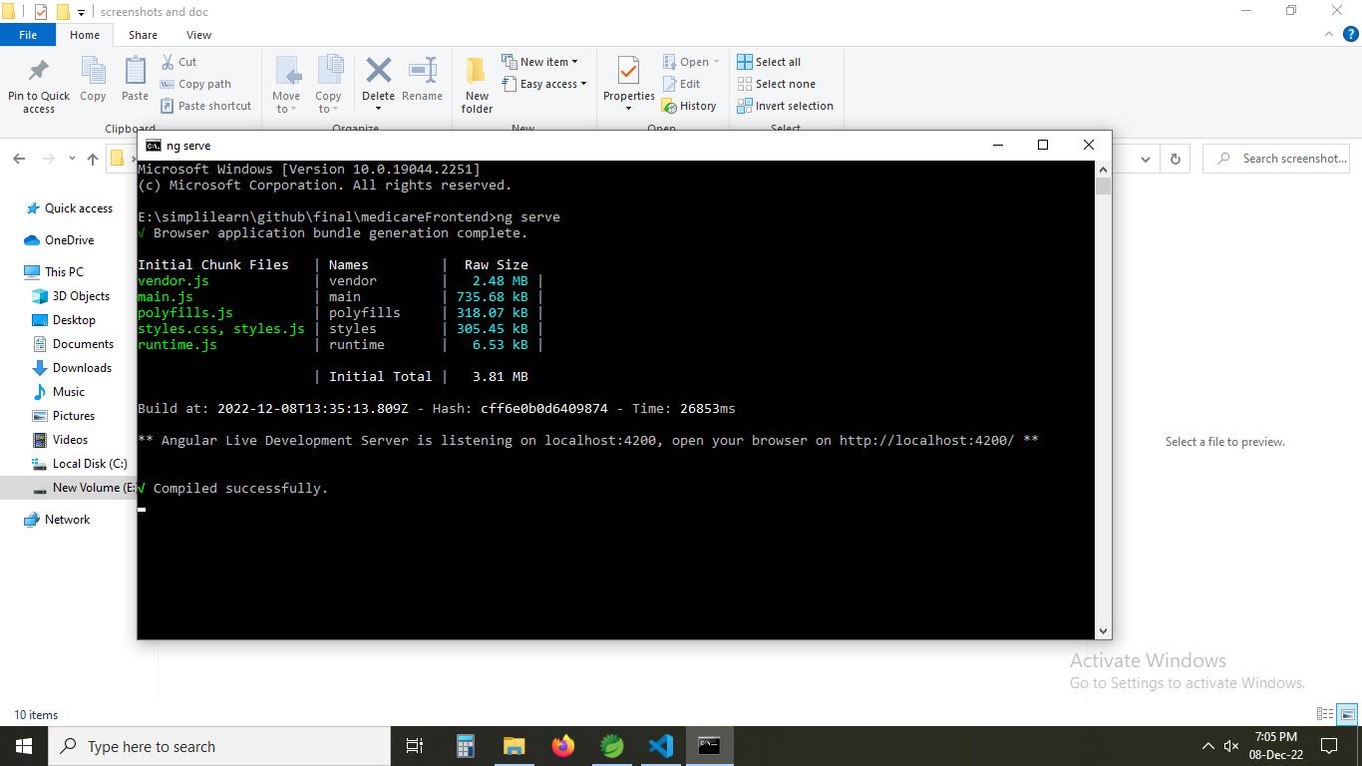

1. **Running localhost:4200/userhome url and Home page is opened.**

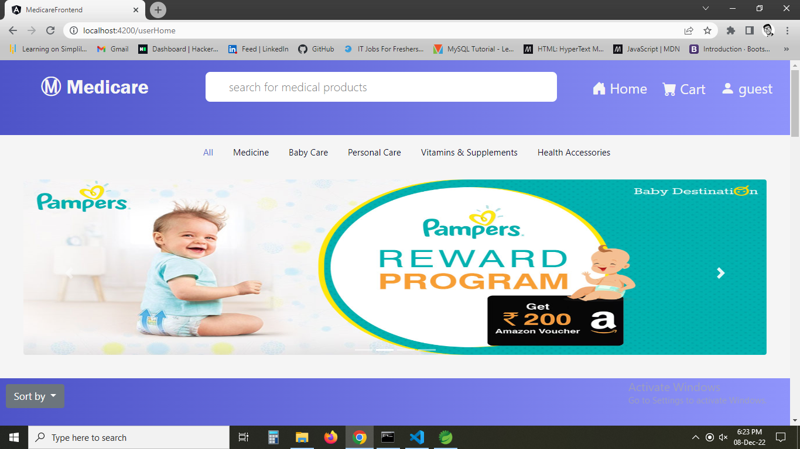

1. **All the products are shown in the website application.**

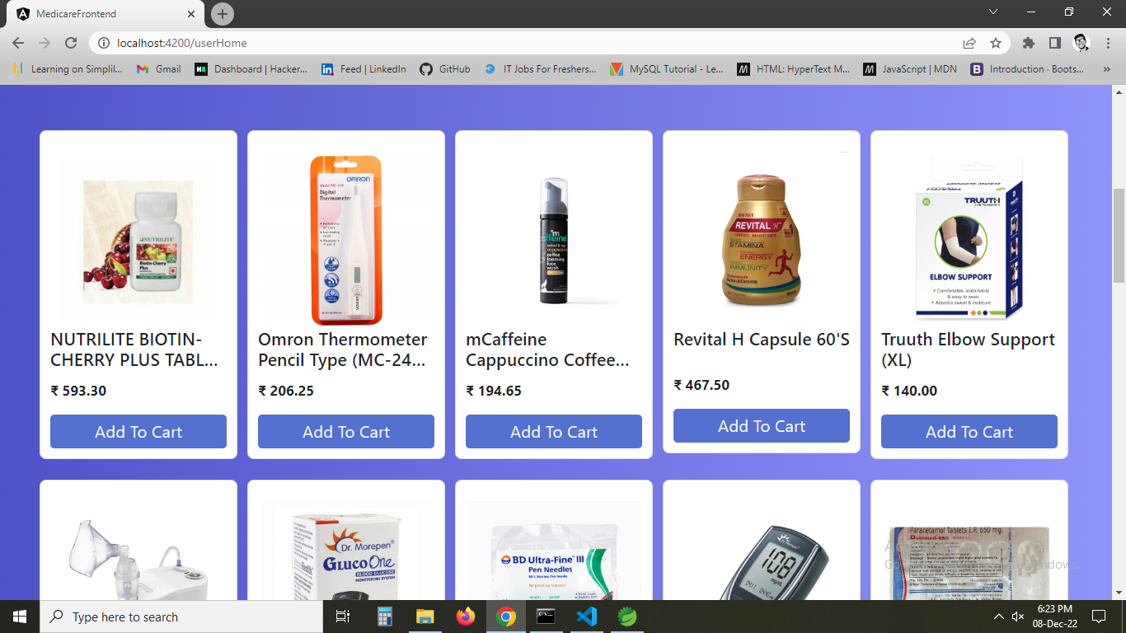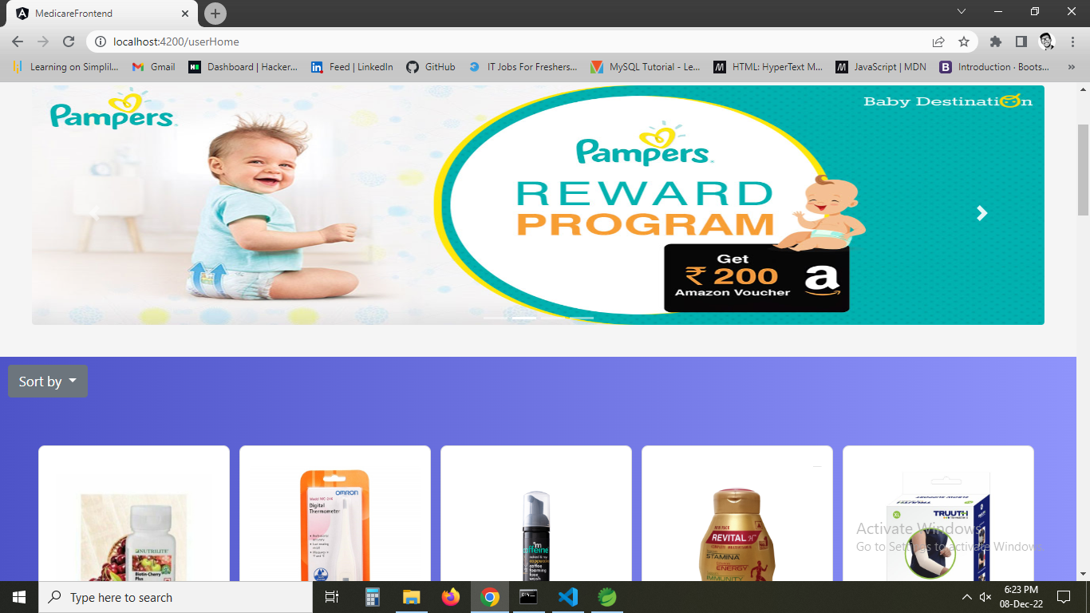

1. **Using Search it is showing product starting with name.**

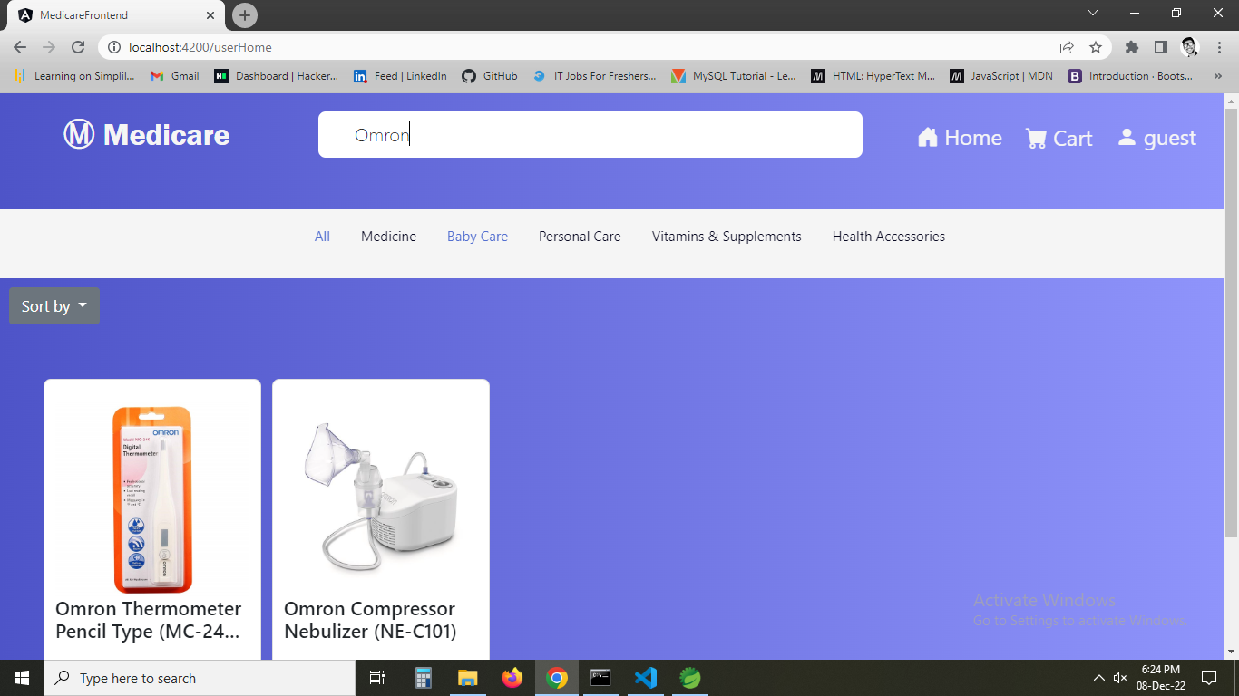

1. **Using nav links as filter product by category.**

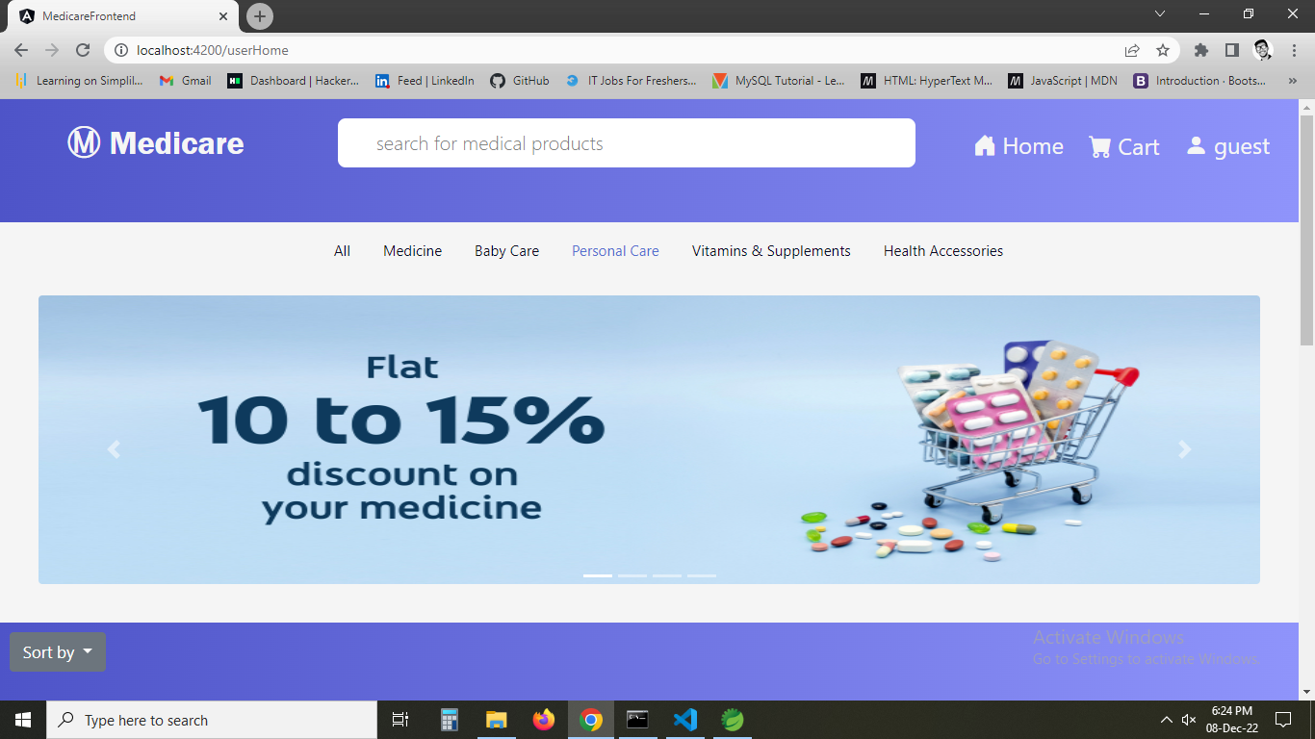

1. **all the products in personal care are shown.**

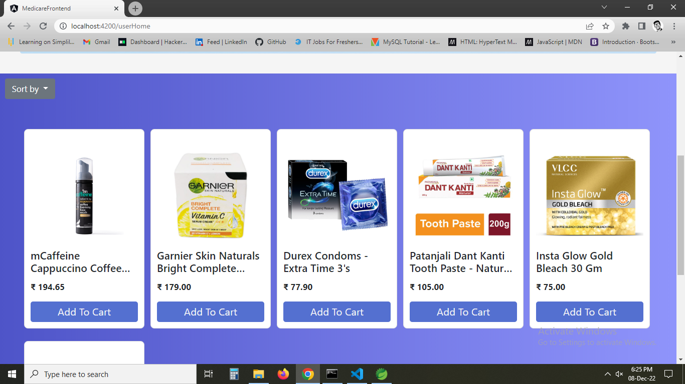

1. **changin category in nav link**

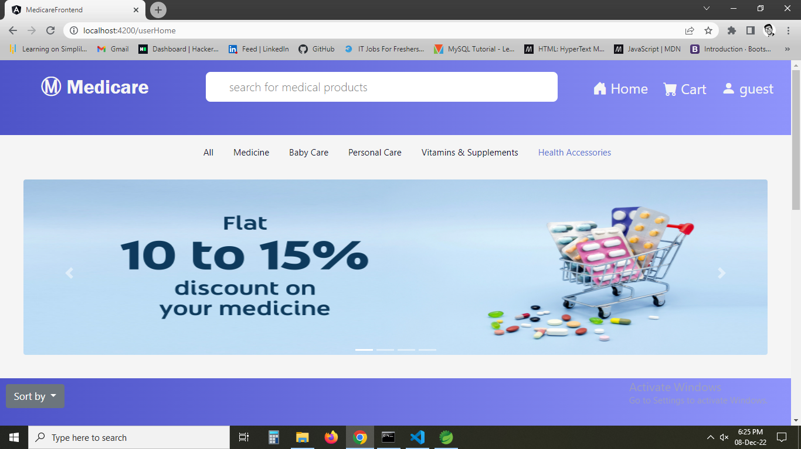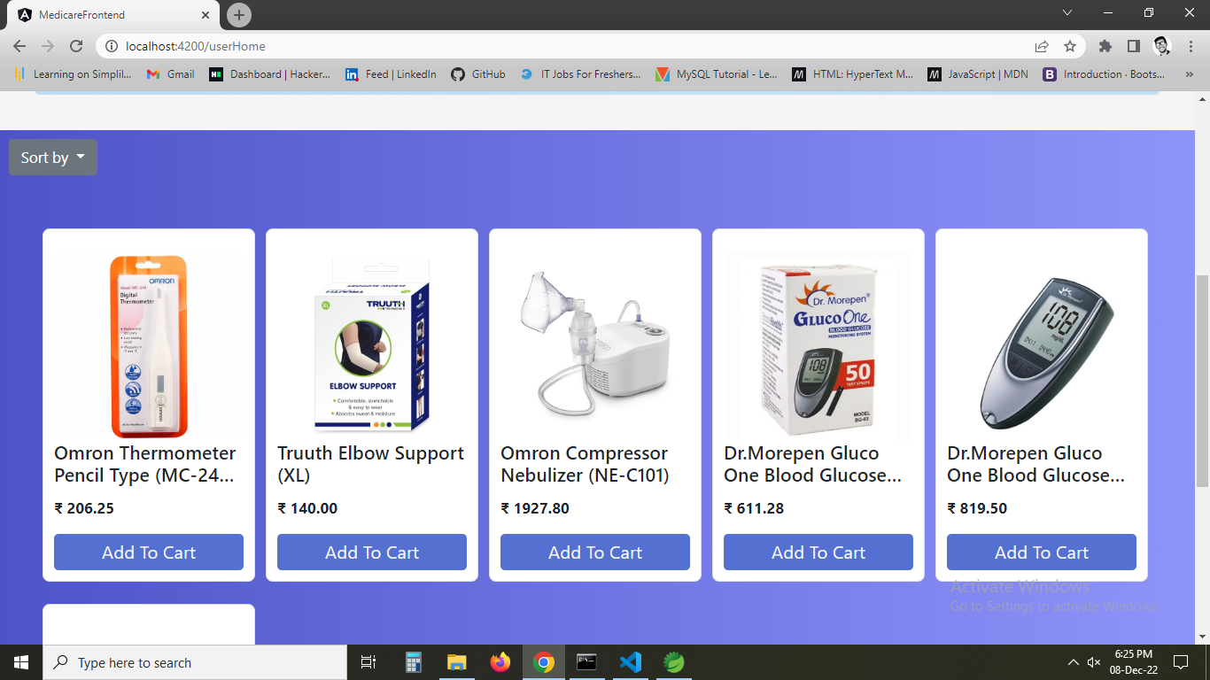

1. **Trying sort by price low to high**

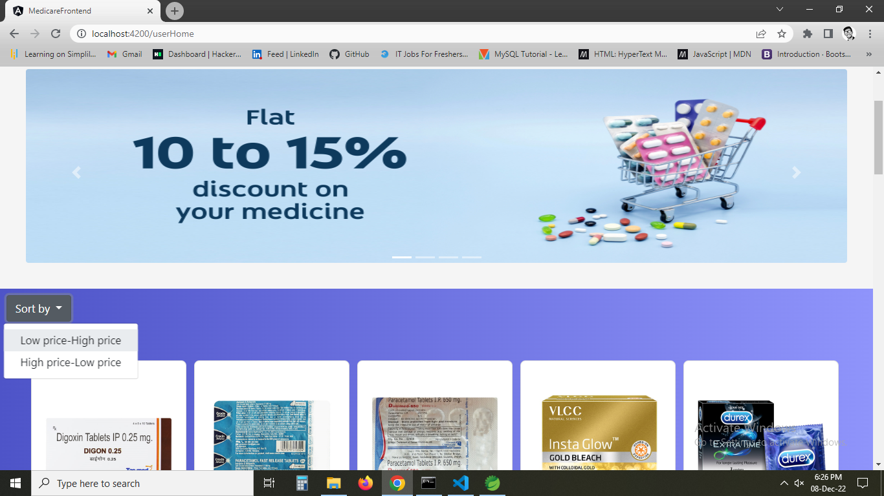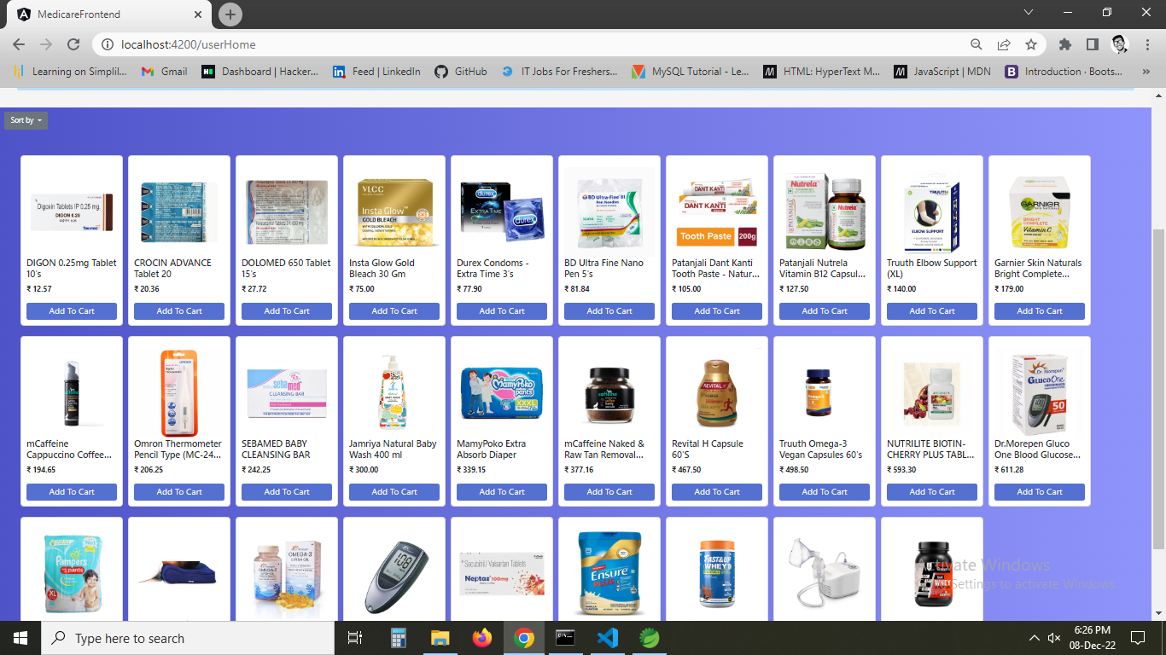

1. **Trying price high to low**

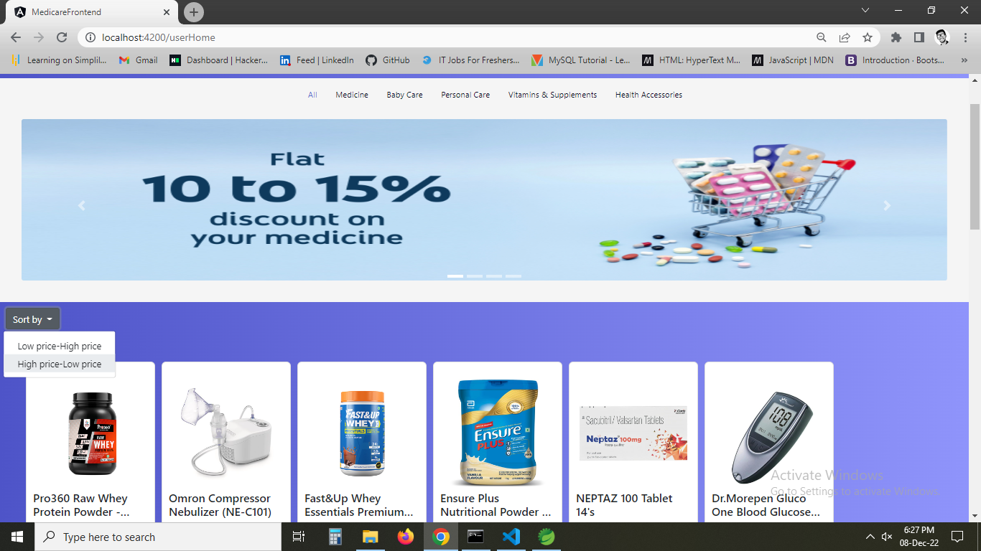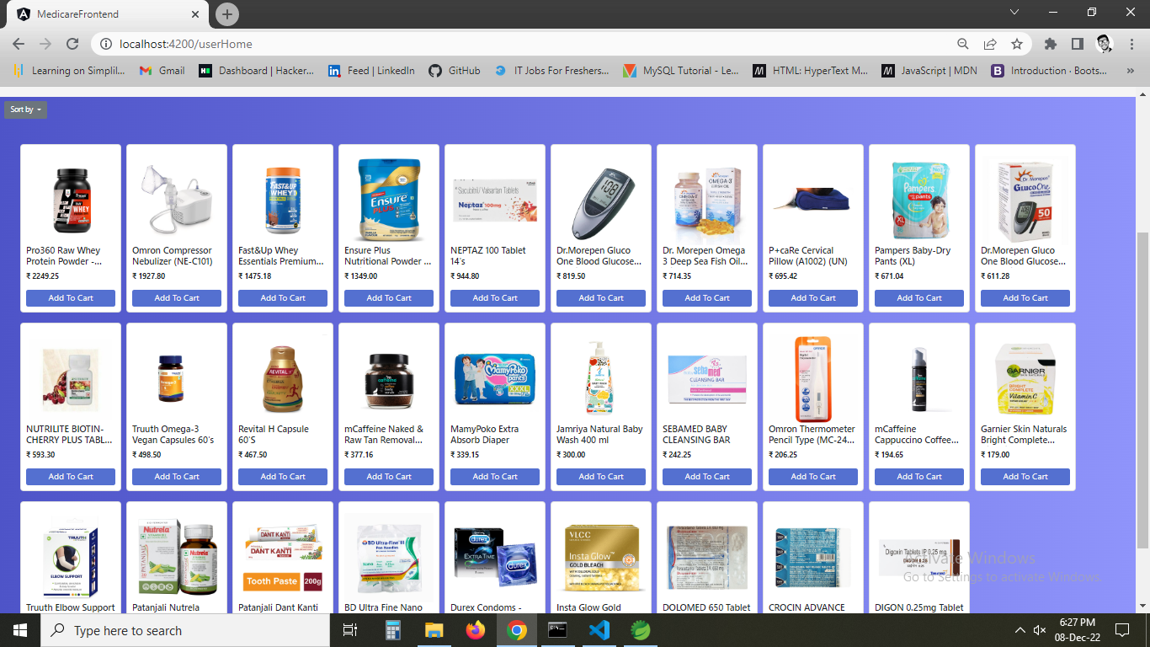

1. **If you click on add to cart or cart button it asks u to login to continue as you are a guest.**

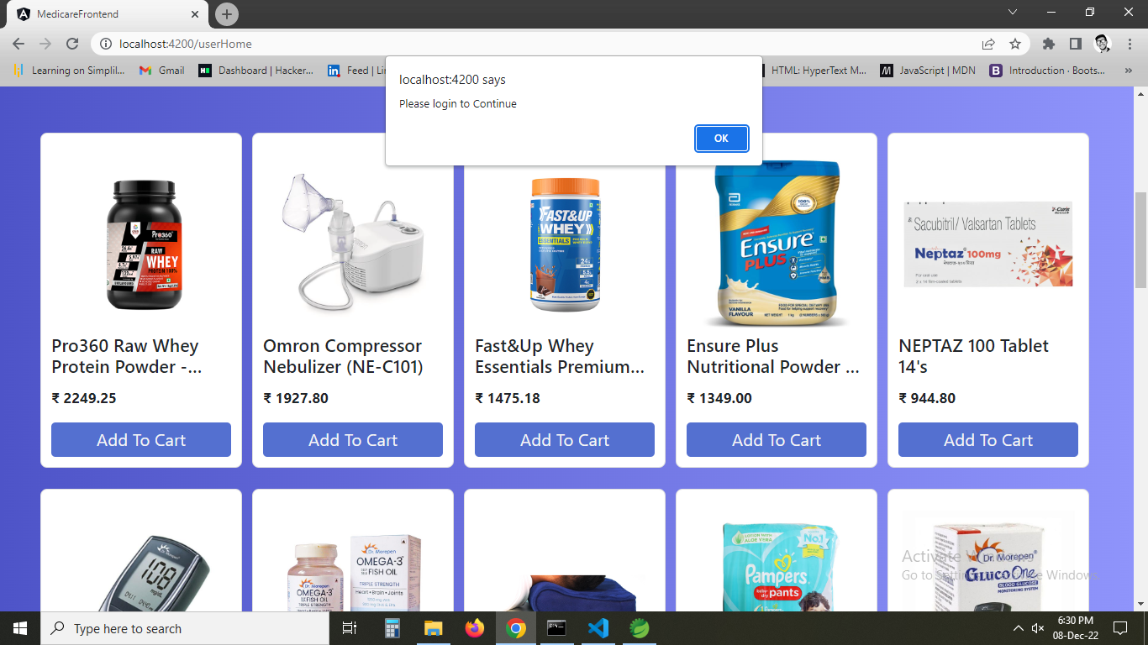

1. **On ok it redirects to a page and now trying admin login.**

**Username:admin**

**Password:admin**

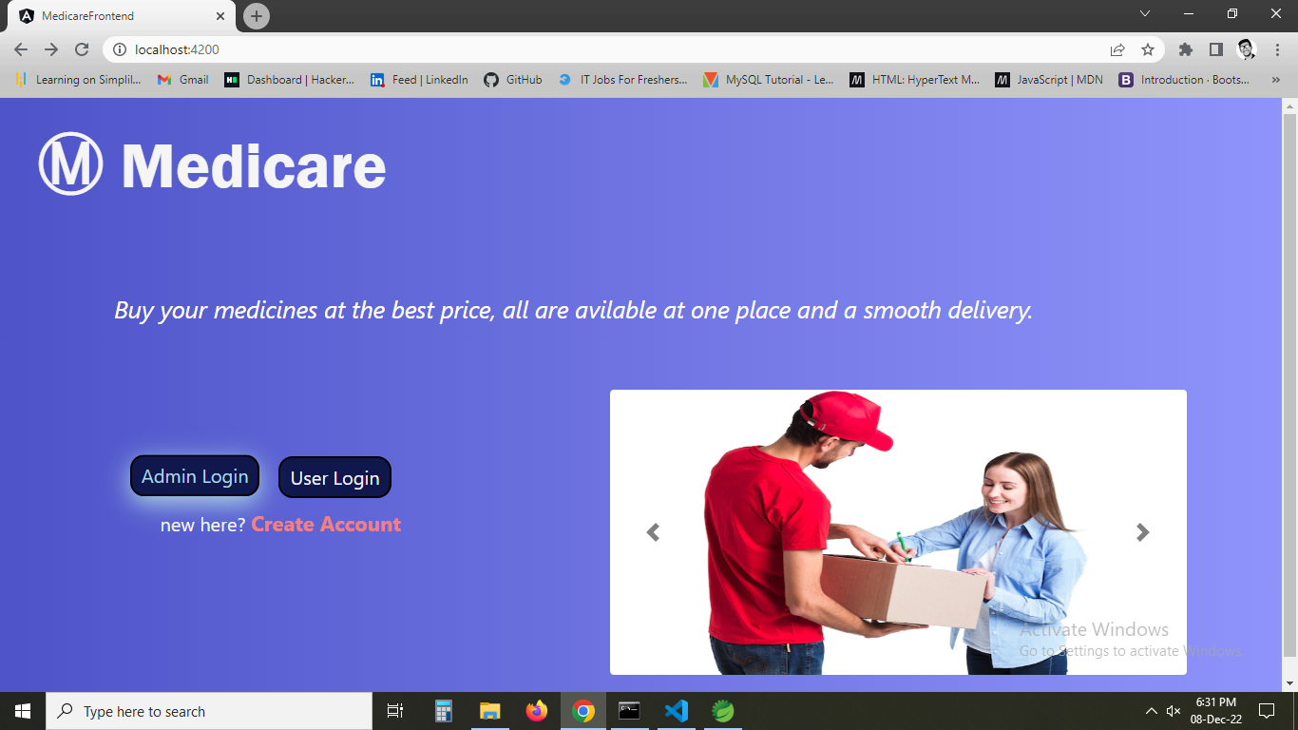

1. **Admin home page is shown where all options are shown**

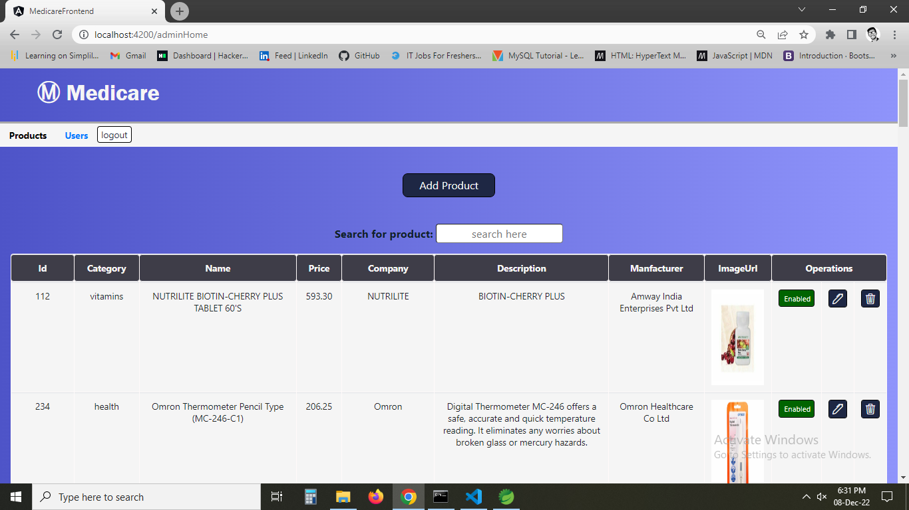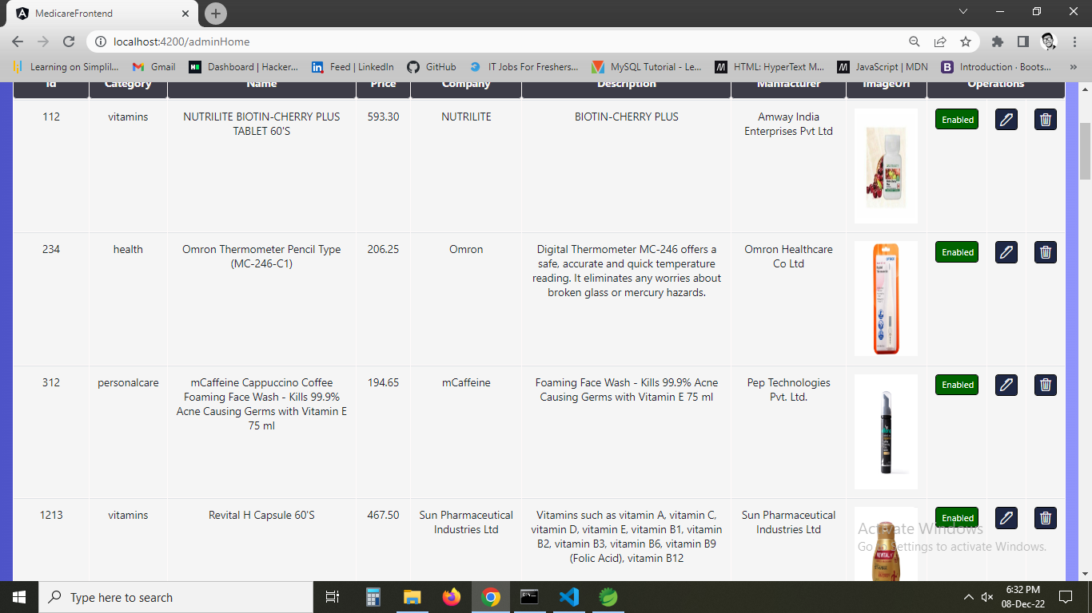

1. **You have enable and disable button to show availability of product or disable the product in case not to show particular product to user.**

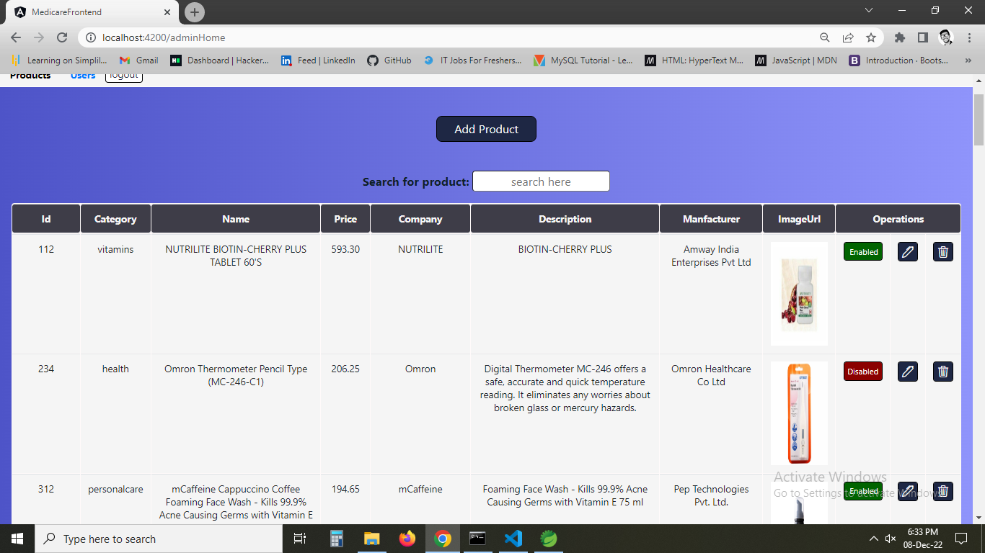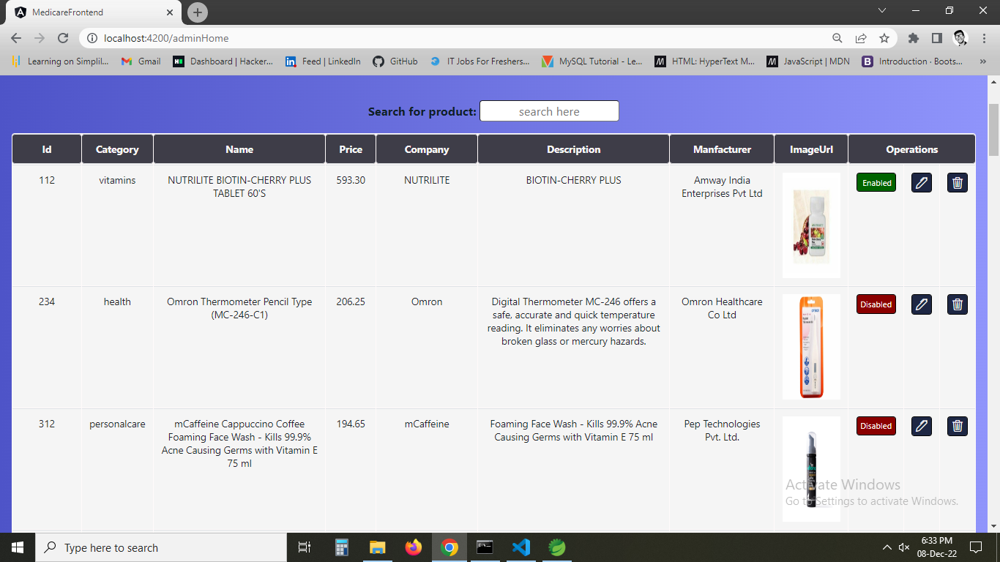

1. **Now trying add product button a form is displayed to show the products.**

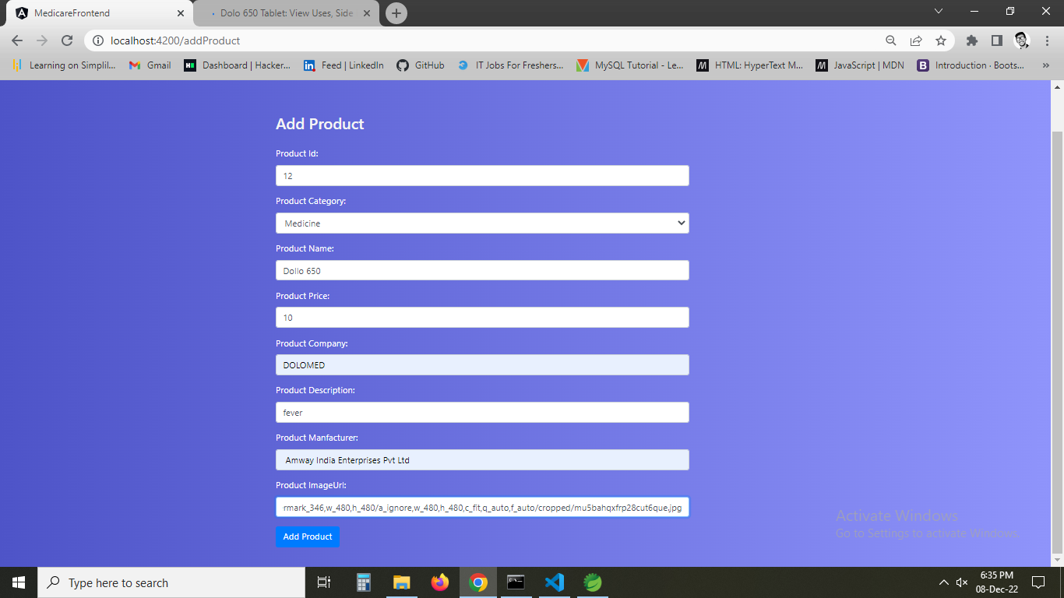

1. **The particular product I entered is shown in the table of data.**

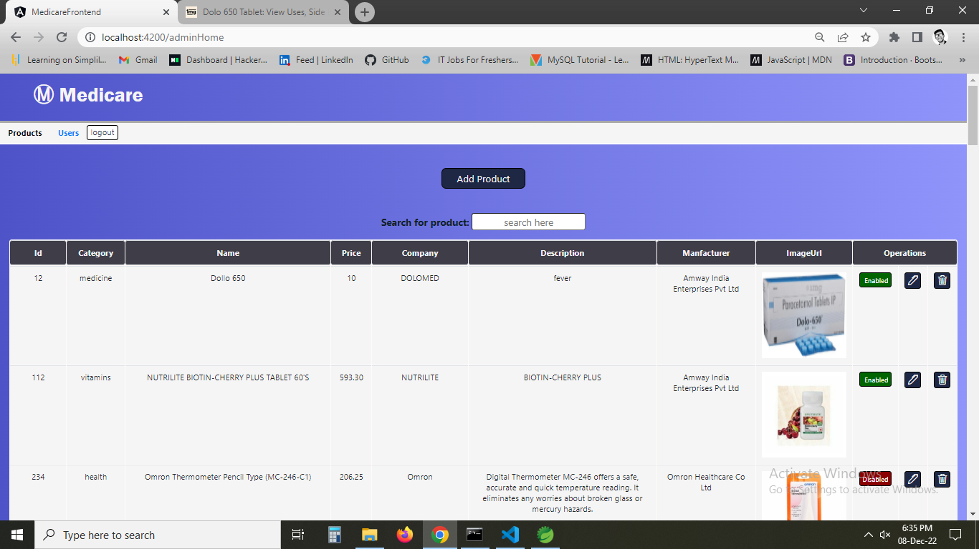

1. **As like that we can edit and if I click delete particular item is displayed.**

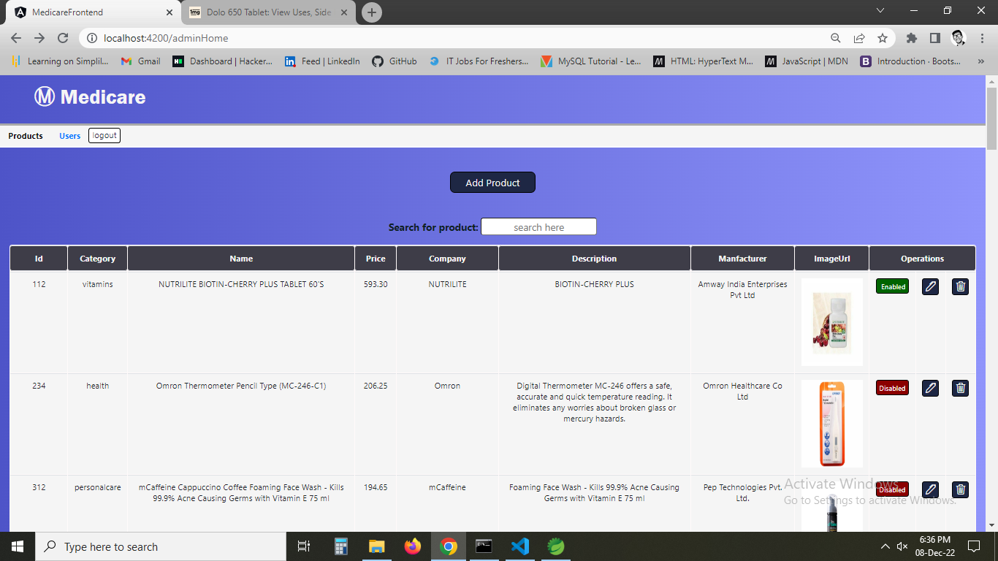

1. **searching particular product with id.**

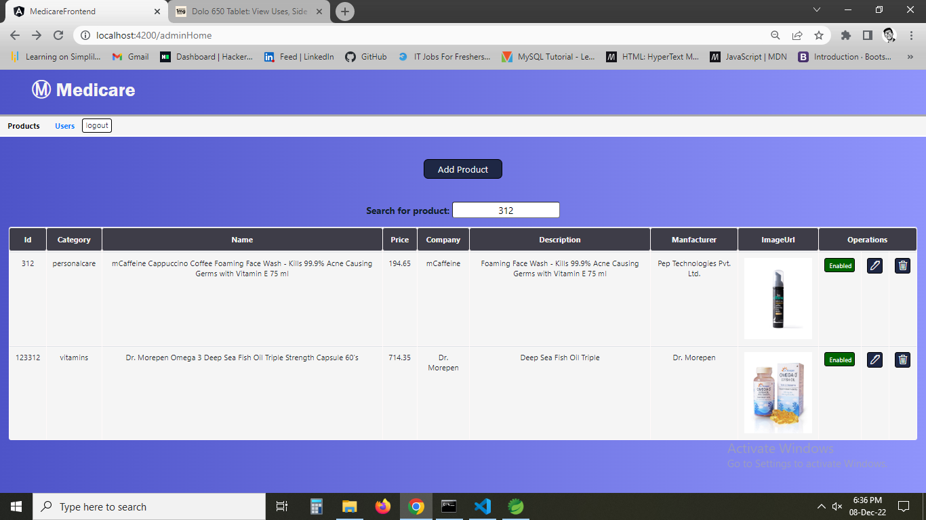

1. **now using user tab all the data of users are shown.**

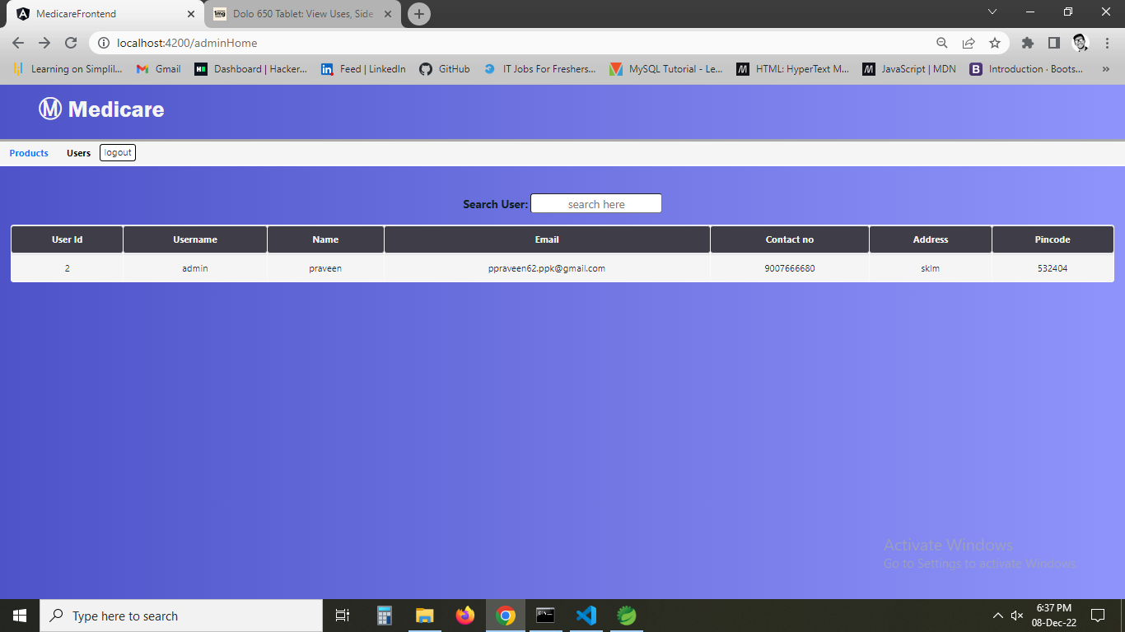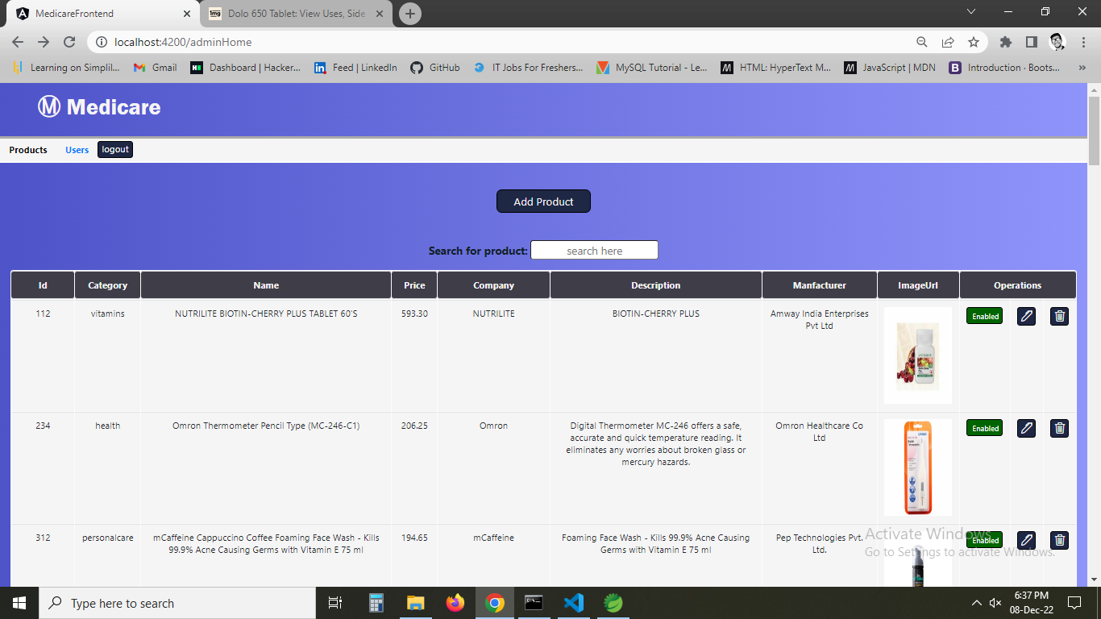

1. **now clicking create account.**

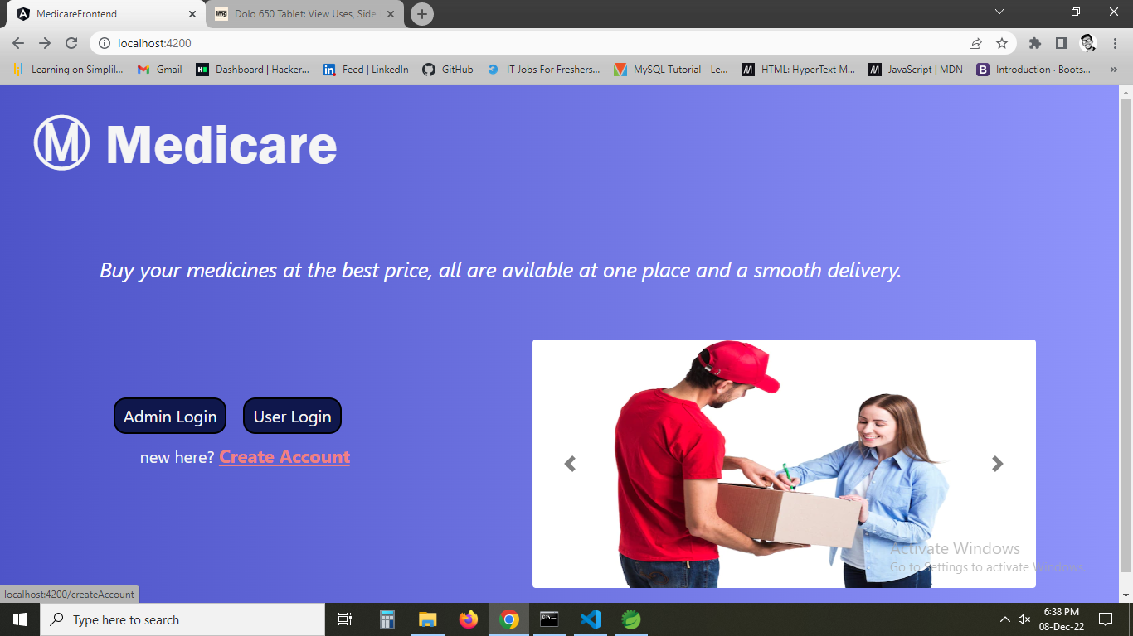

1. **the form to create account is dispalayed.**

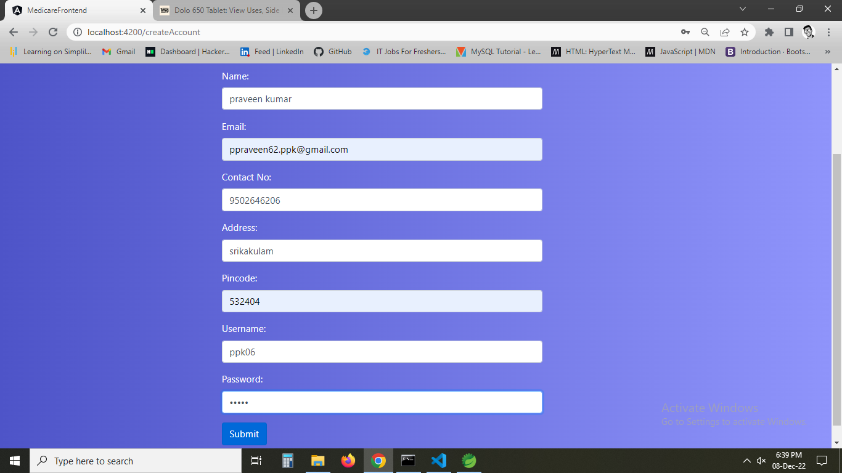

1. **now using userlogin.**

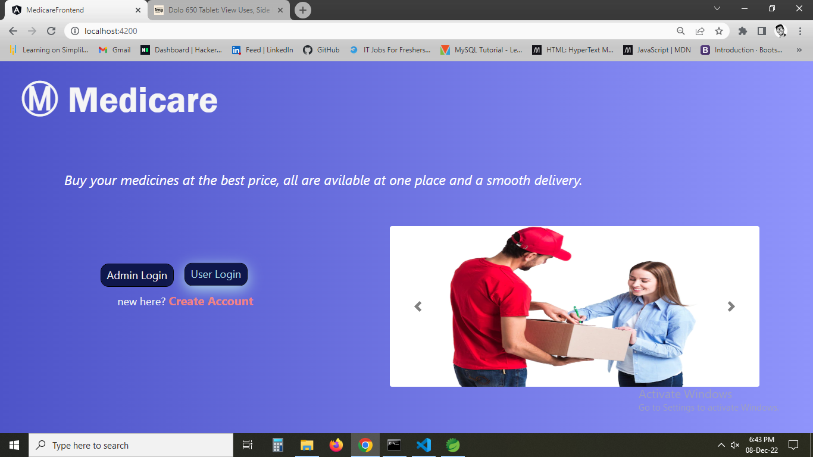

1. **Giving data**

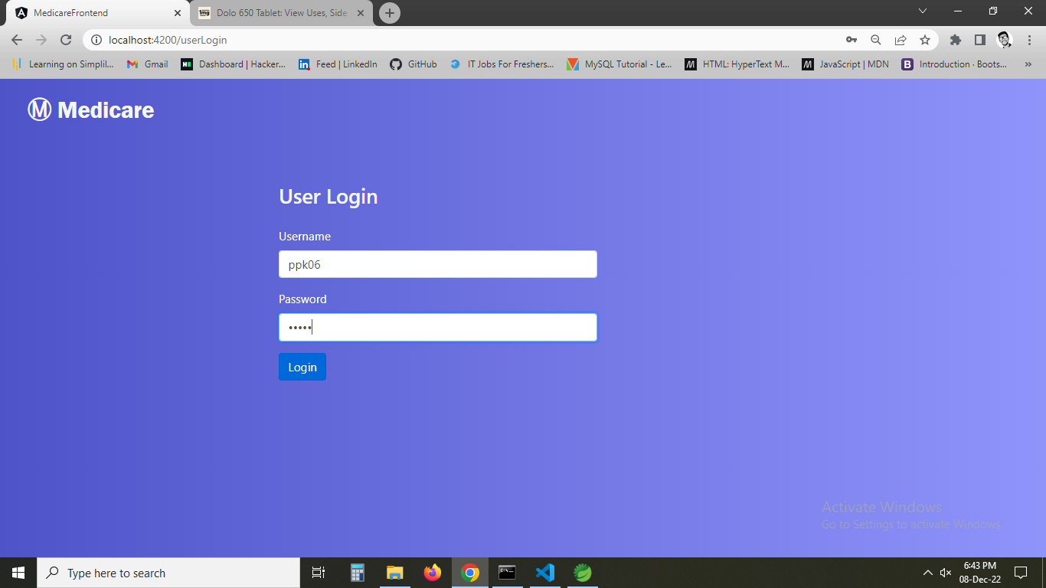

1. **Home page with username is displayed.**

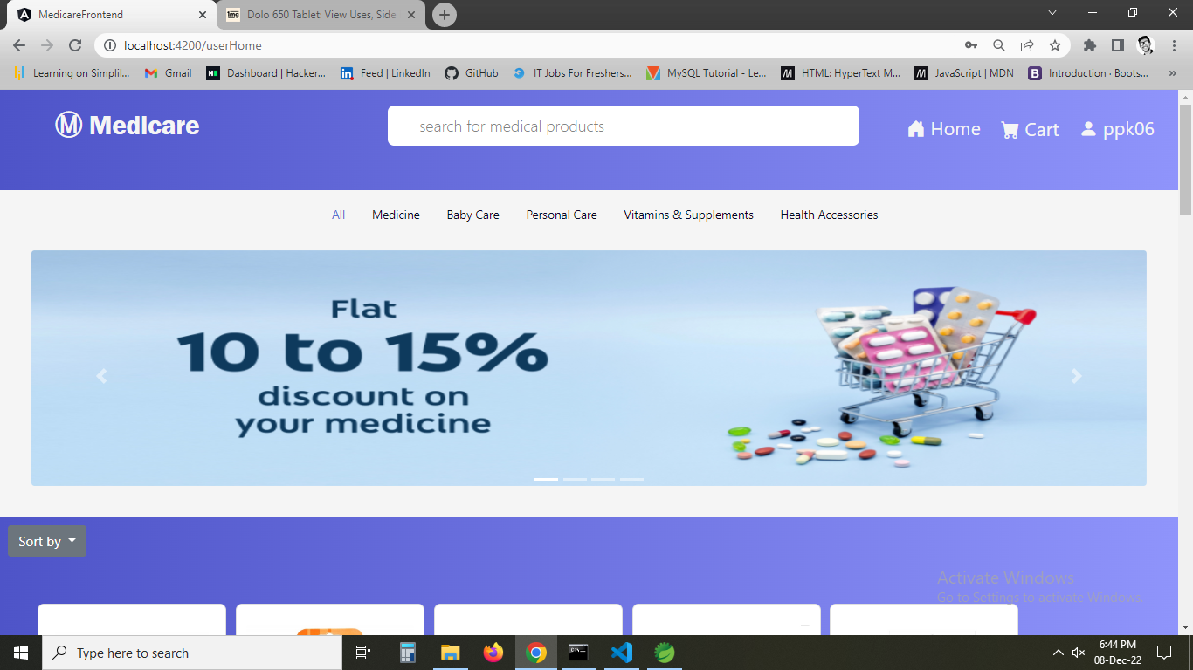

1. **Checking my cart showing no items**

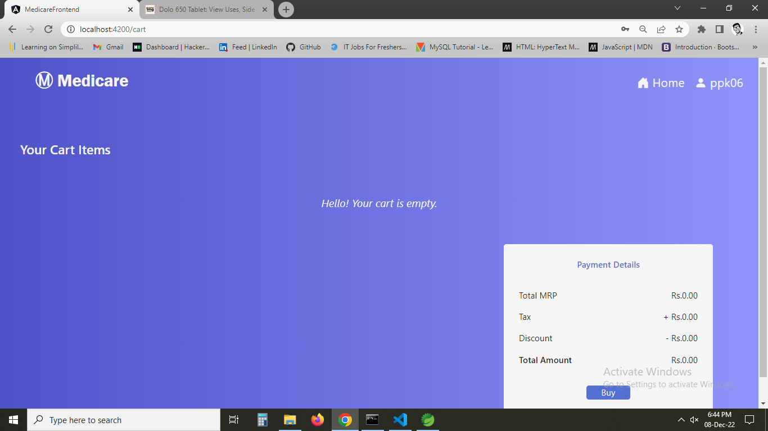

1. **Now trying to add items to cart it is showing successfully added to cart.**

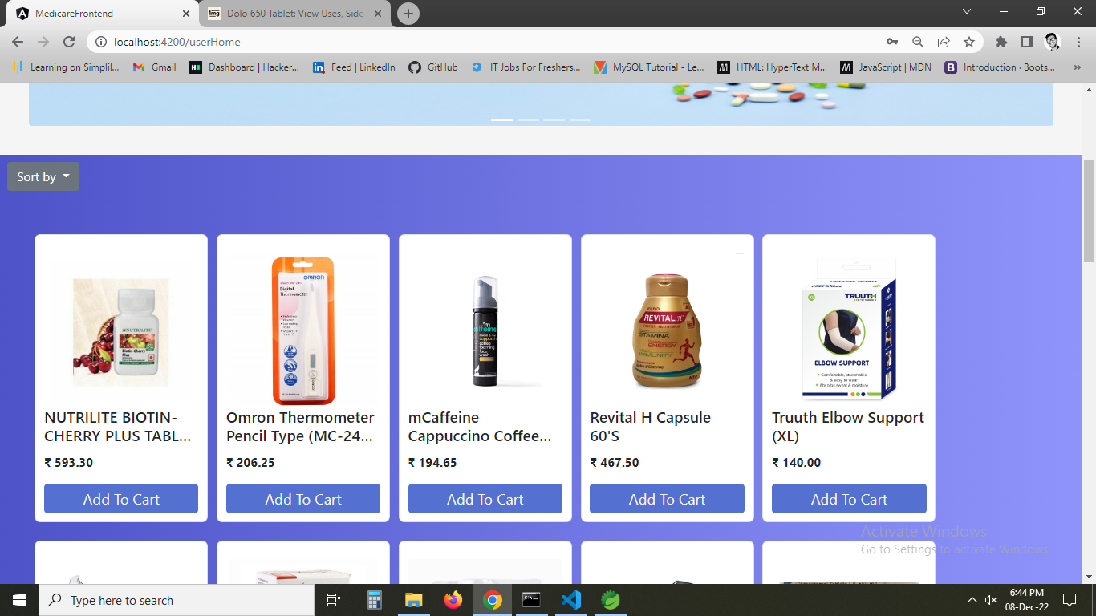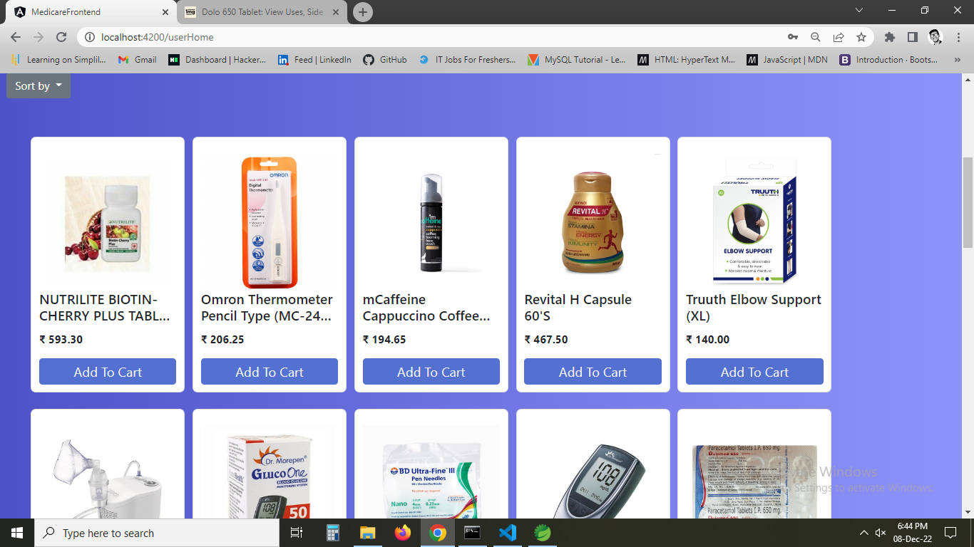

1. **All the added items are added to cart and payment details are shown.**

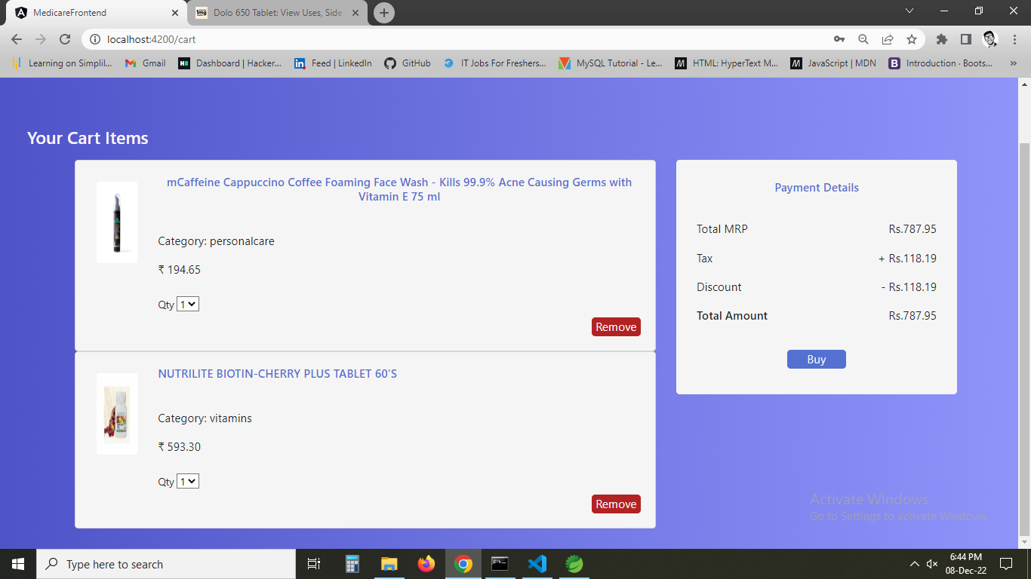

1. **Now removing item from the cart and the price is also updated.**

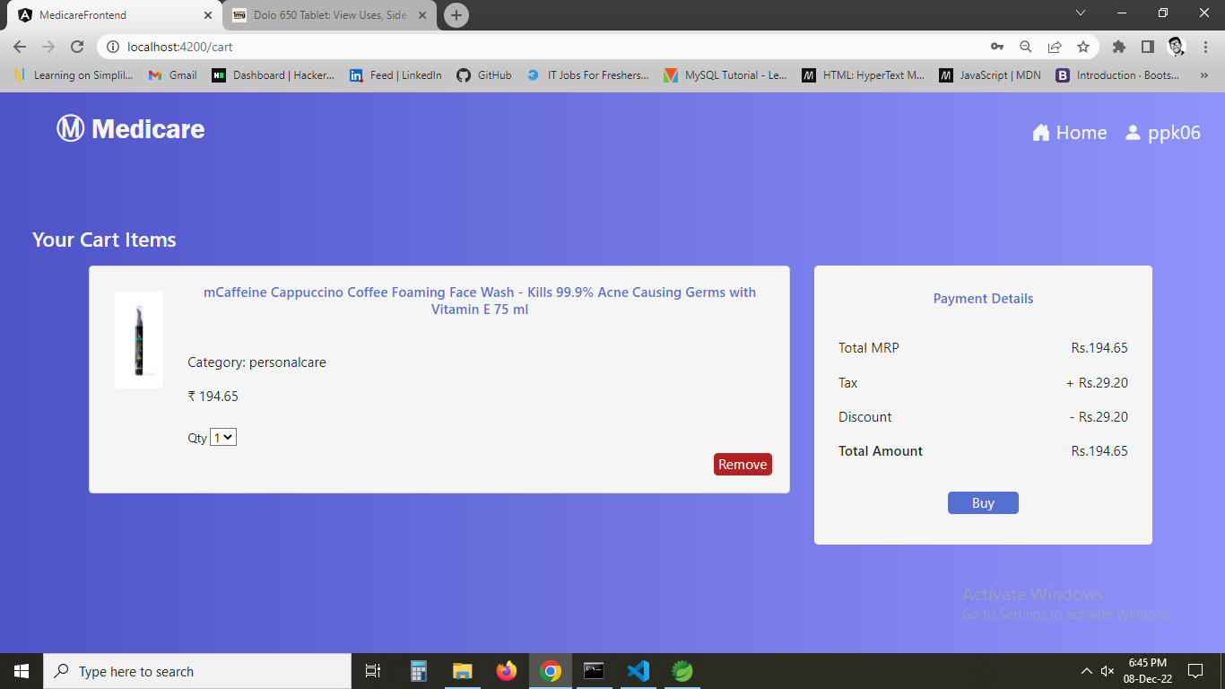

1. **Now on clicking Buy. Order summary is shown and card details are asked for further .**

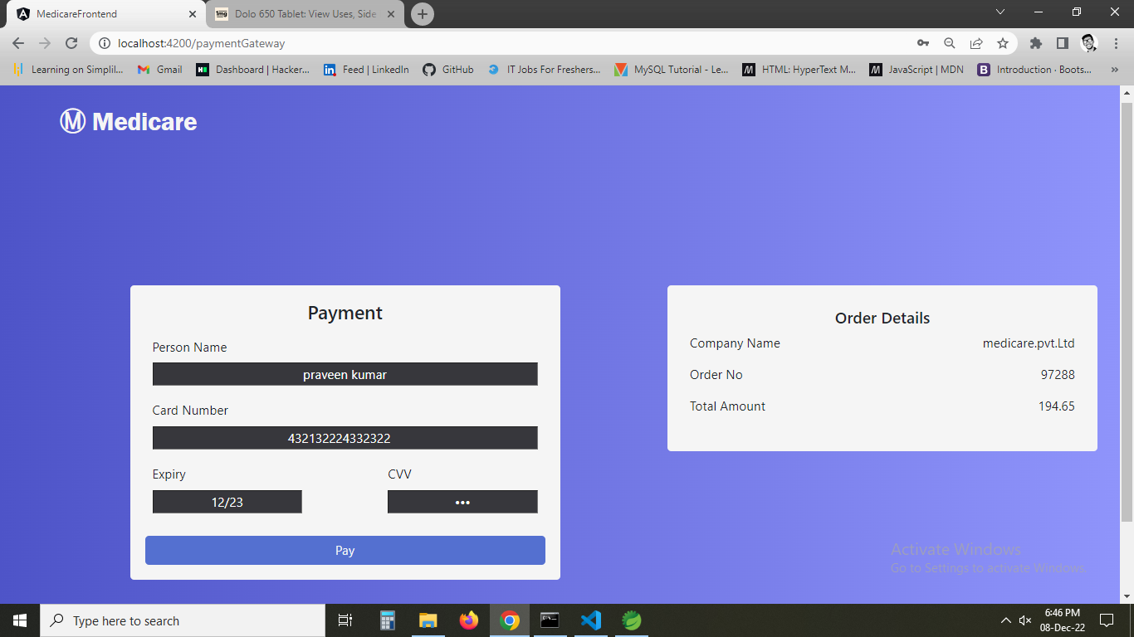

1. **On payment Order confirmation is shown with order no.**

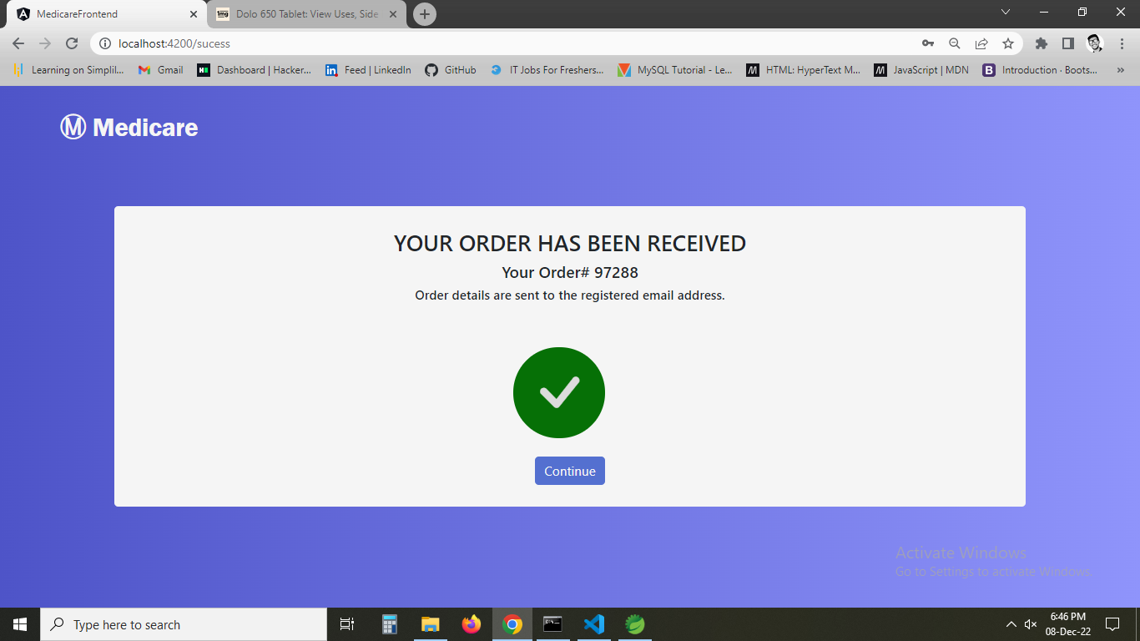

1. **Now going back to home page and checking orders**

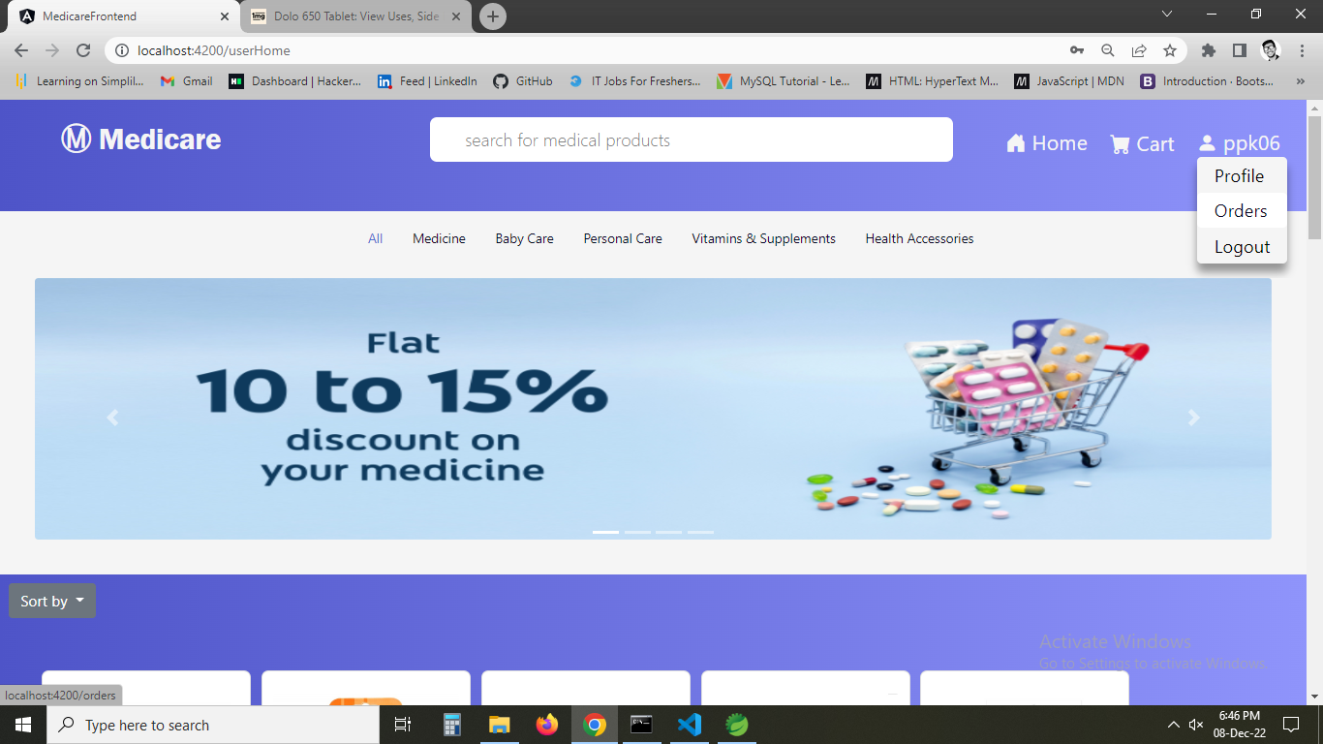

1. **Showing details of previous orders.**

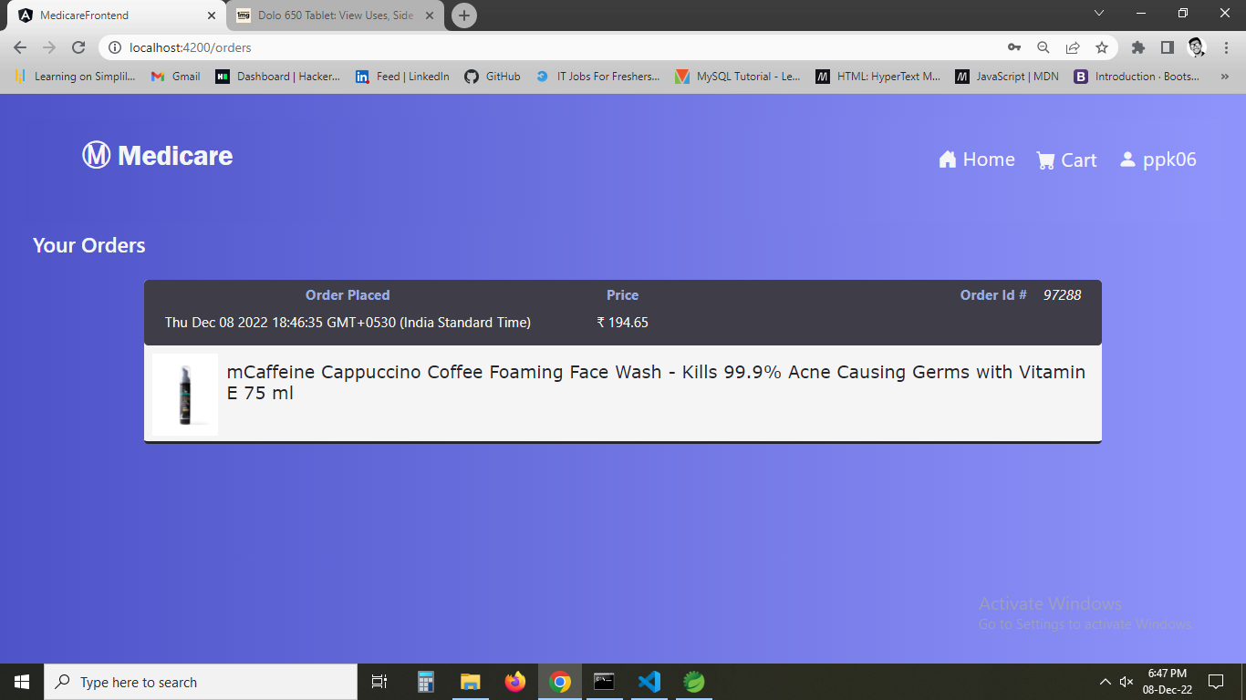

1. **Now again checking cart**

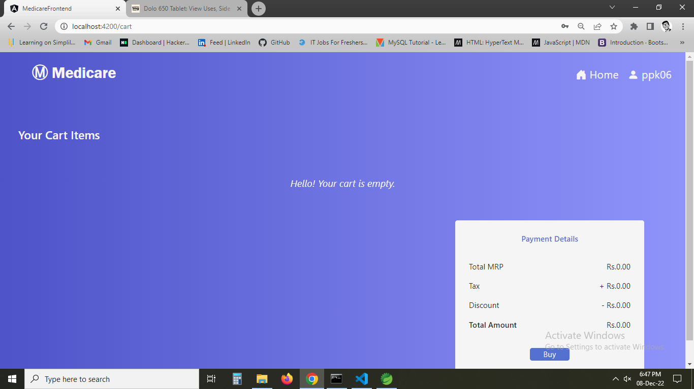

1. **Checking profile**

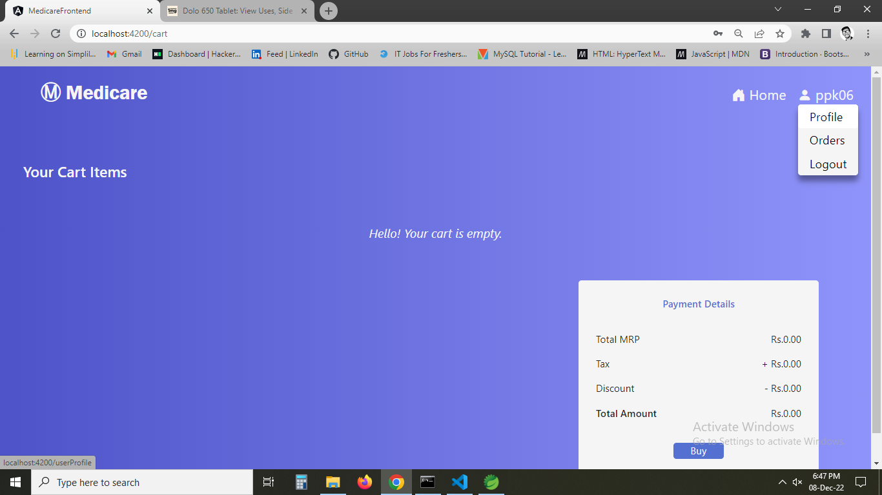

1. **Now profile data is shown and we can update profile here**

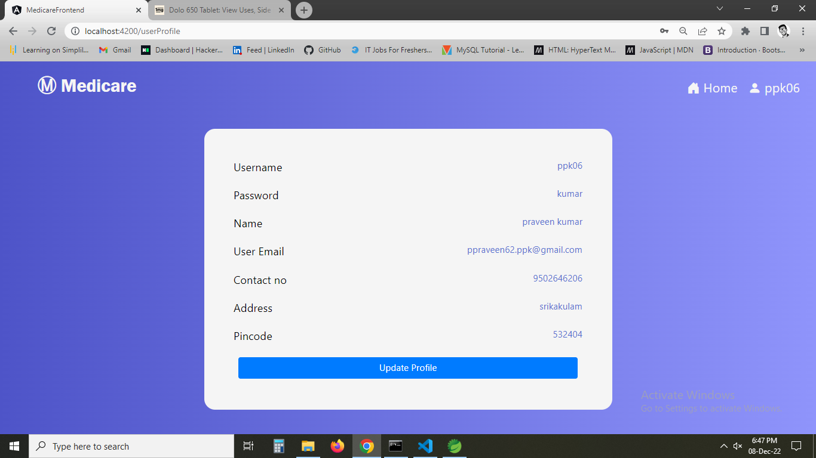

1. **On clicking particular product, product data are shown.**

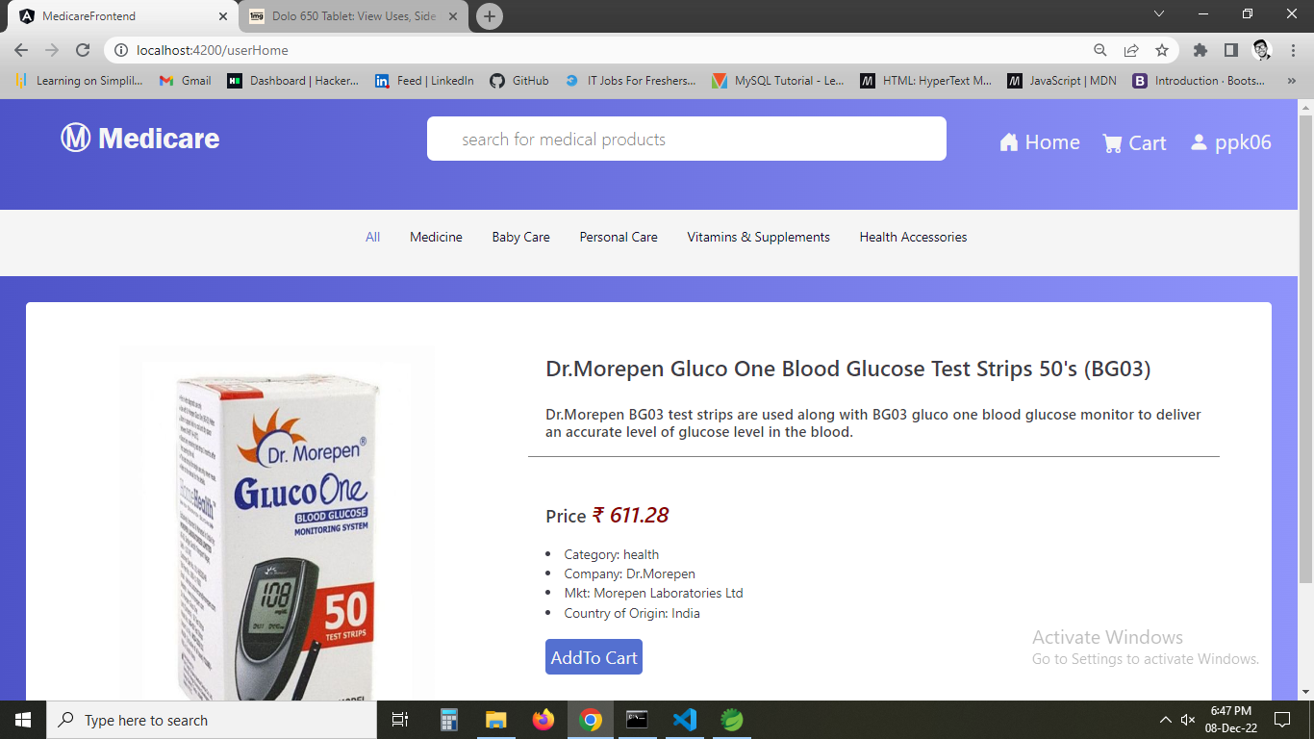

1. **Updating in github.**

**<https://github.com/Adzi17/Mediacare-SL.git>**

**Links to the GitHub repository to verify the project completion**

For source code please use github link.

https://github.com/Adzi17/Mediacare-SL.git